- Install nginx and run nginx on port number 81.
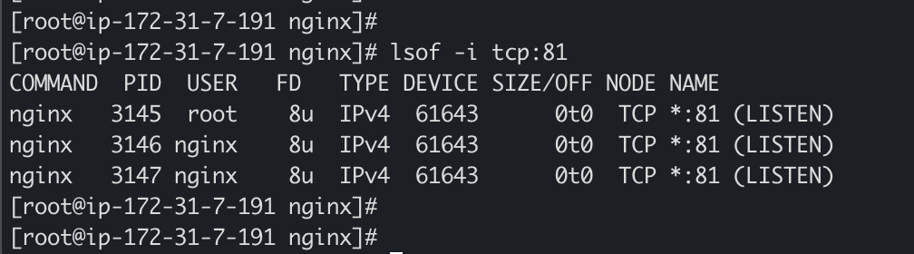
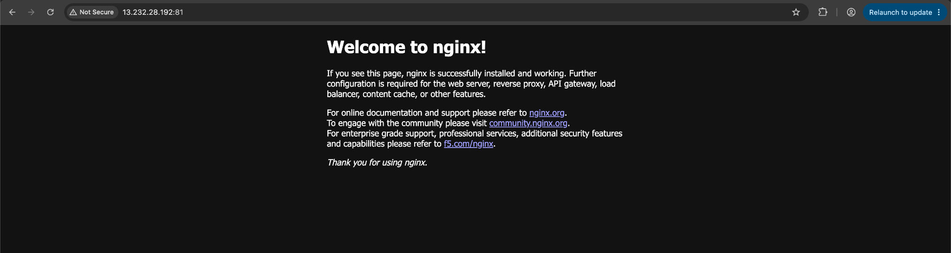

- Deploy a sample index.html file on nginx.

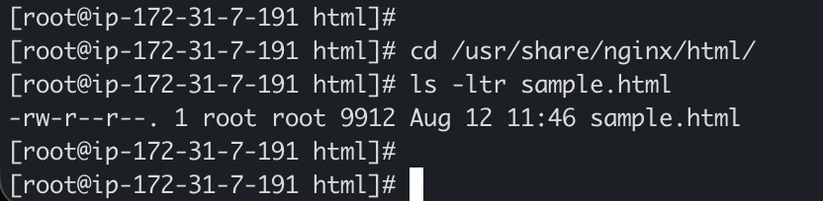

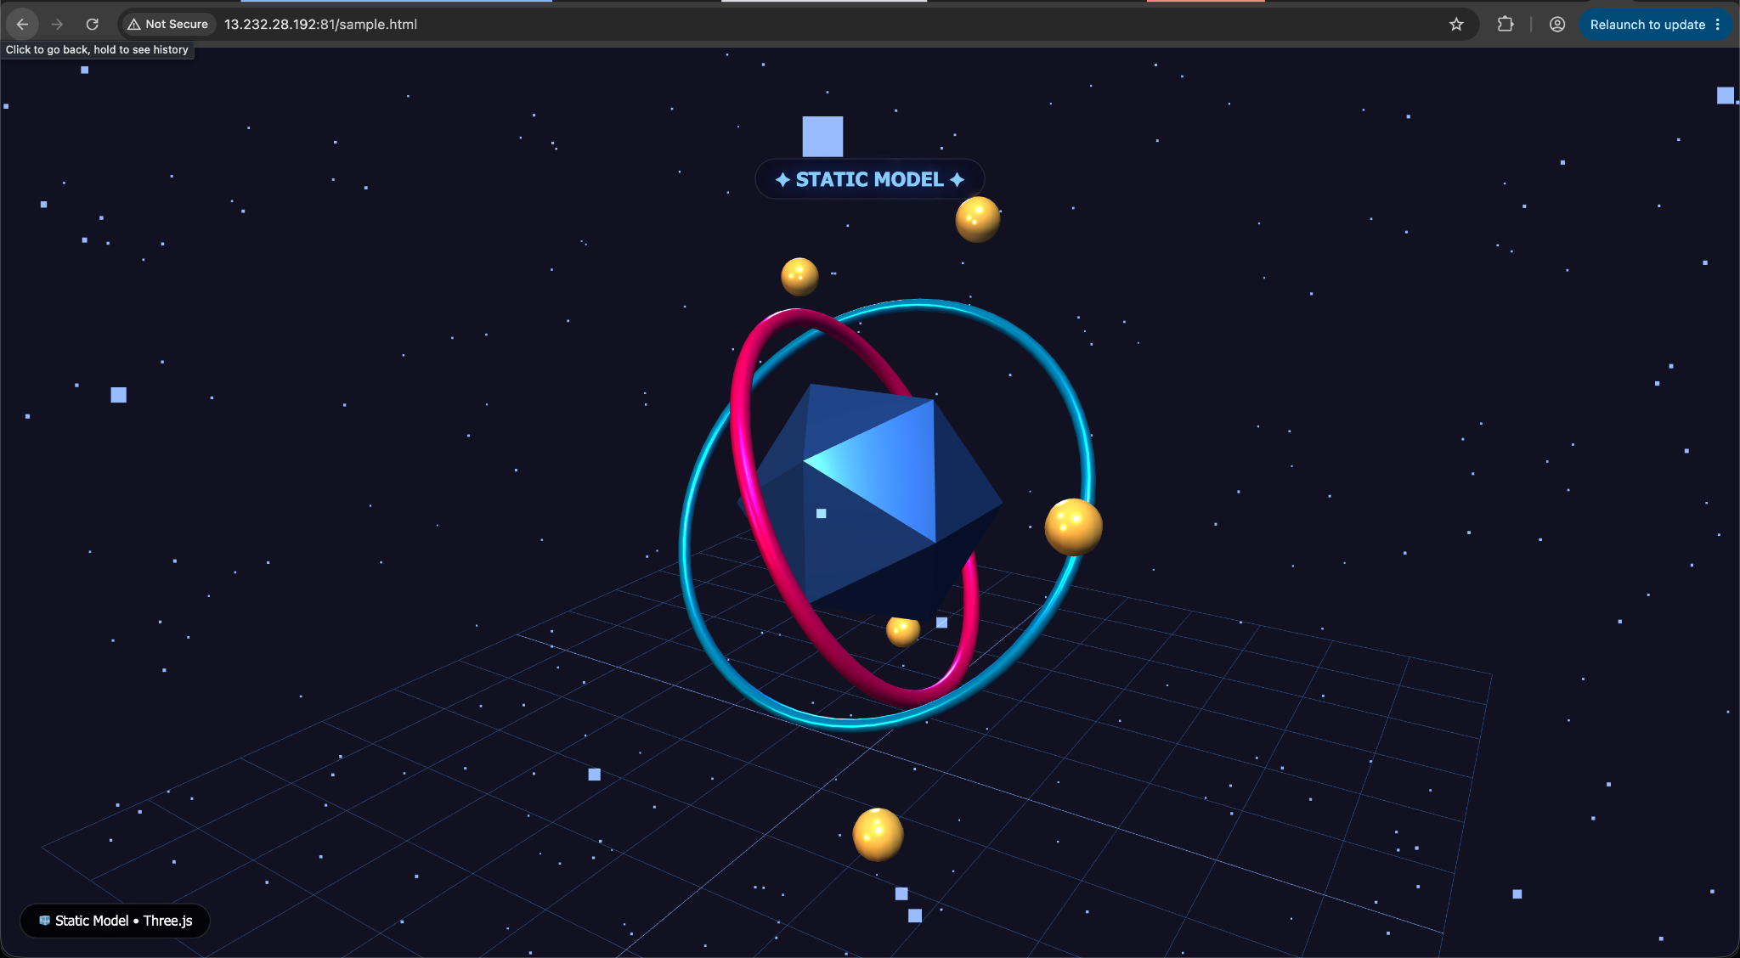

- Install Apache and run Apache on port number 82
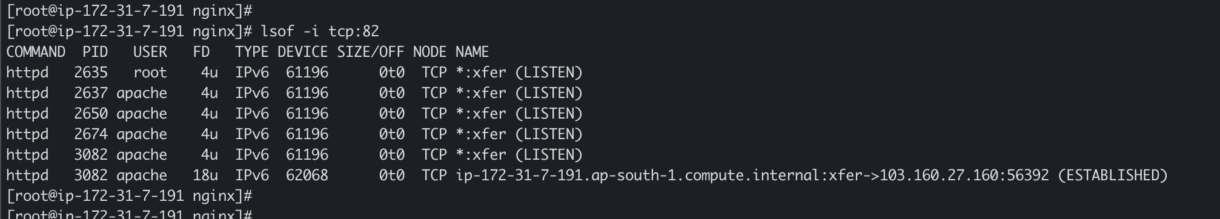

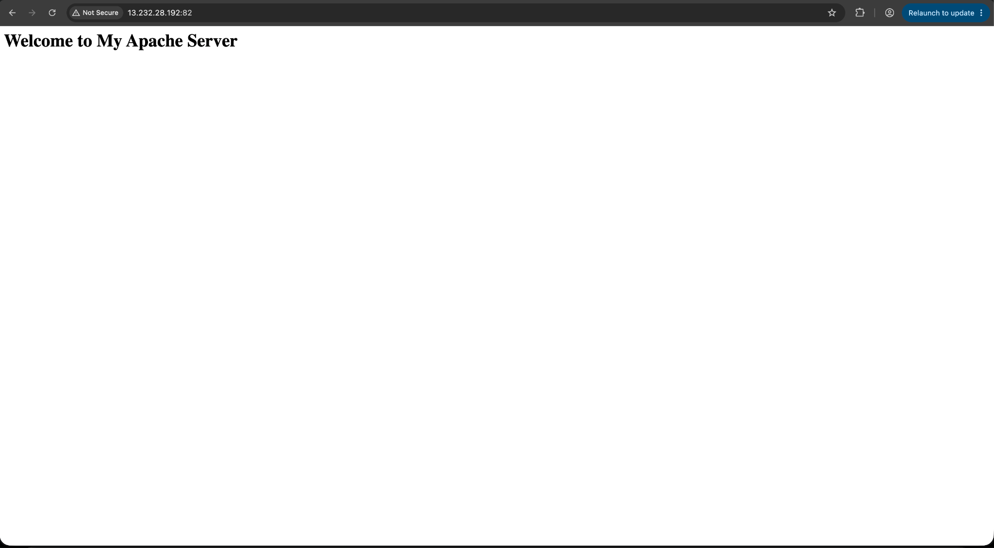

- Deploy a sample index.html file on Apache.

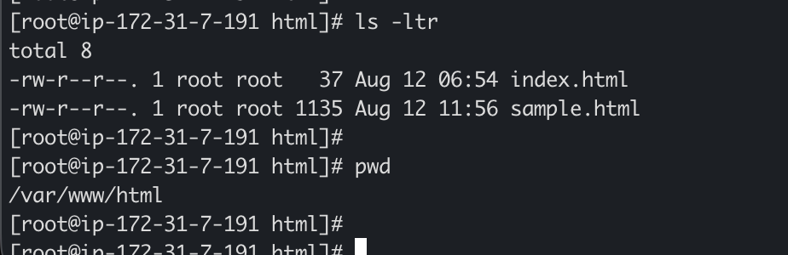

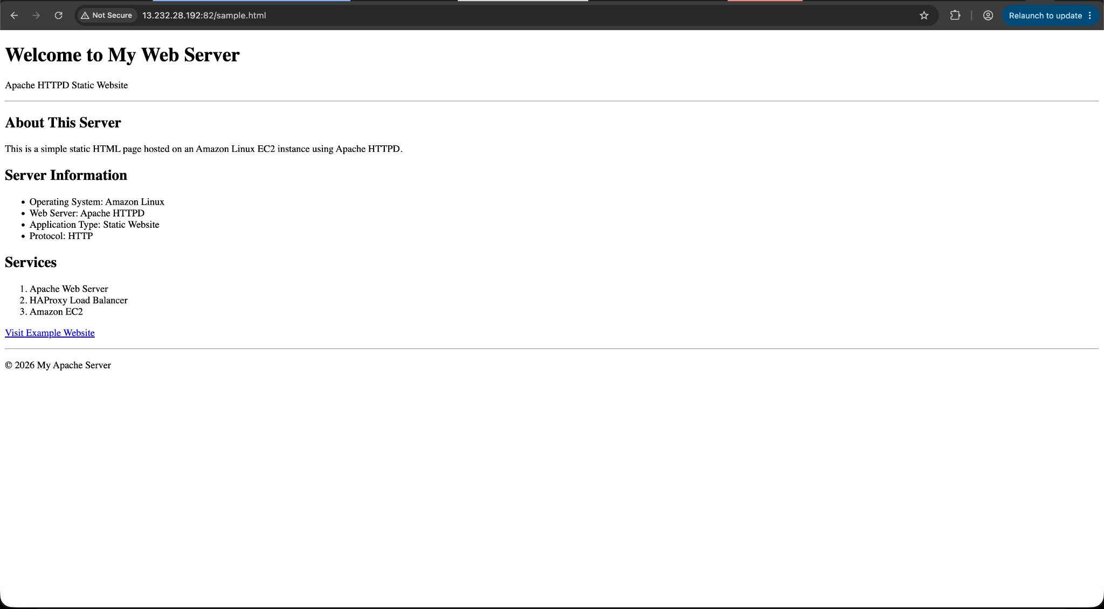

- Install Apache tomcat on port number 8082

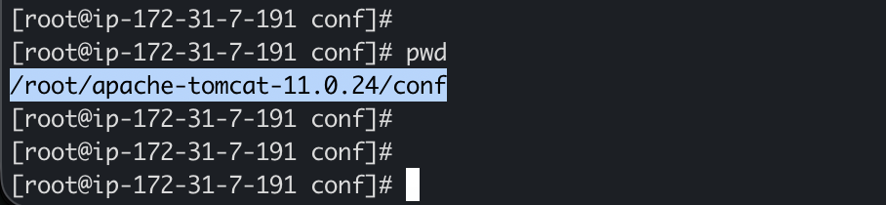

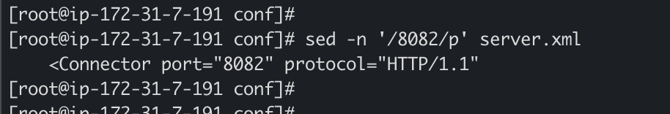

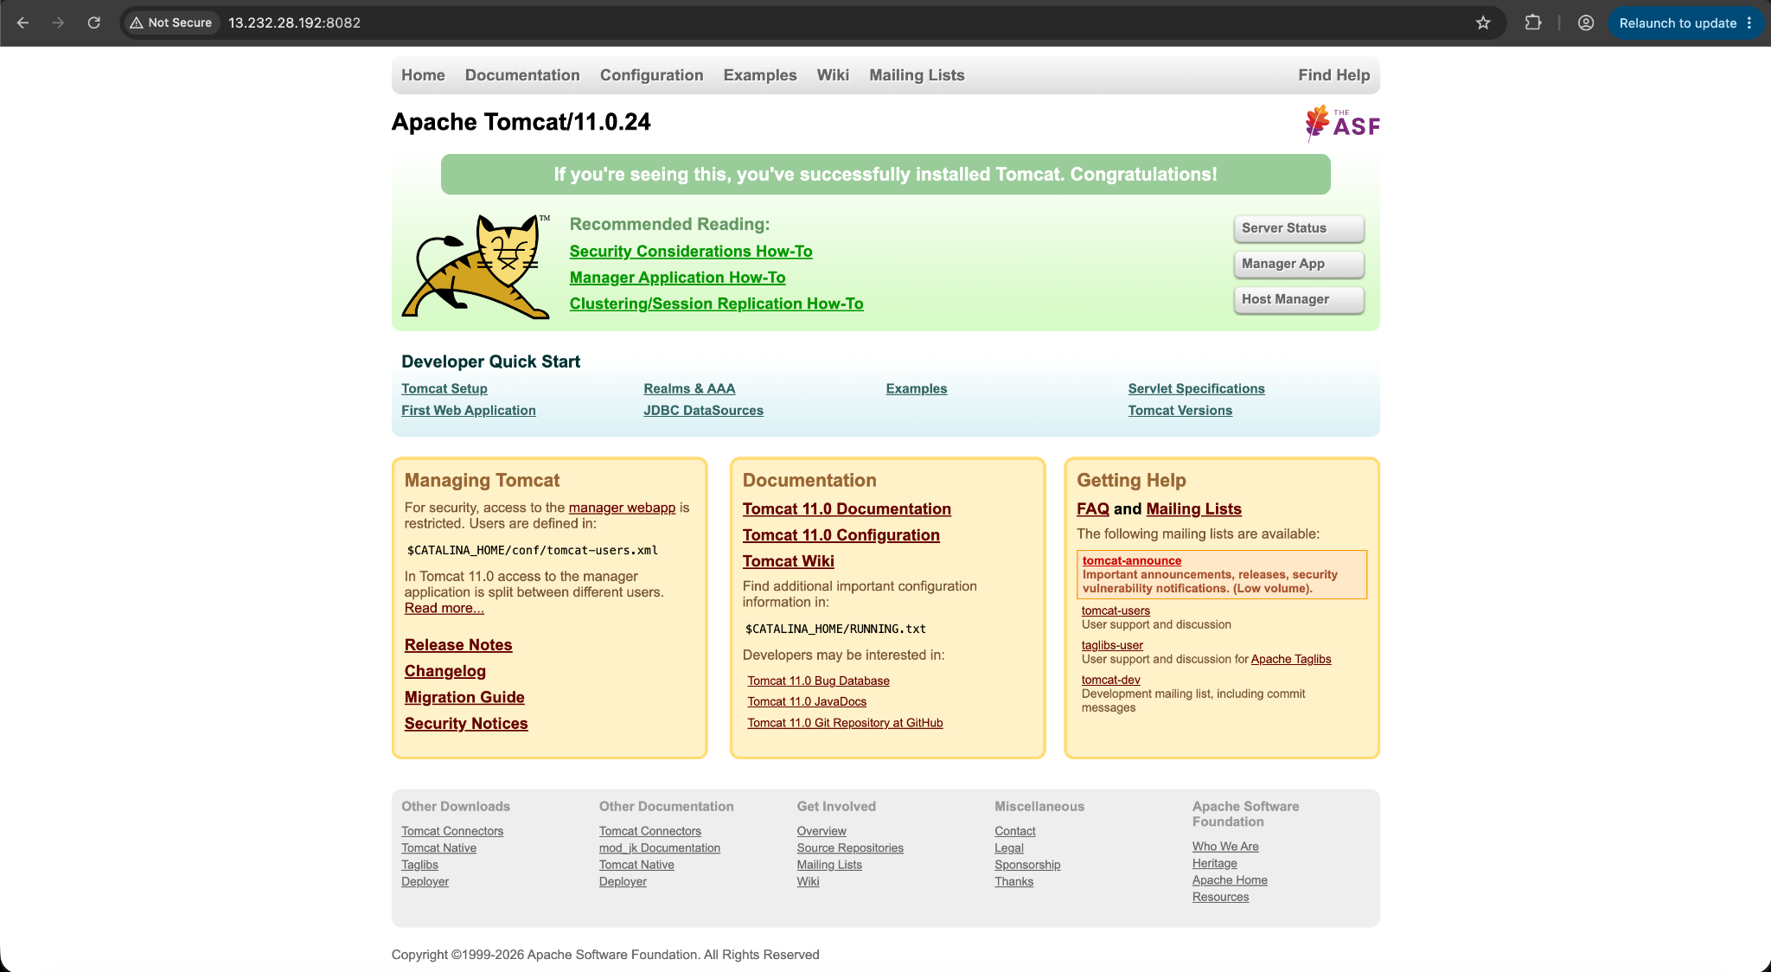

- Deploy a sample app on webapps

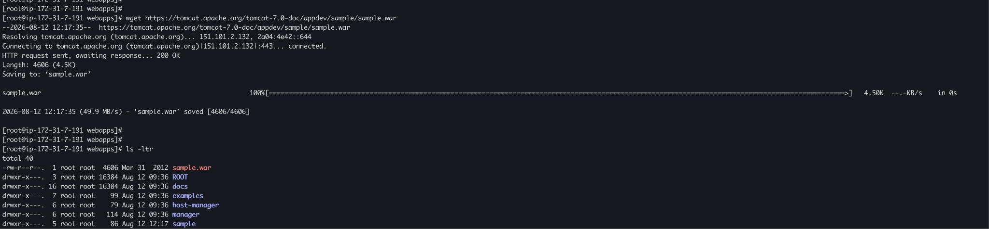

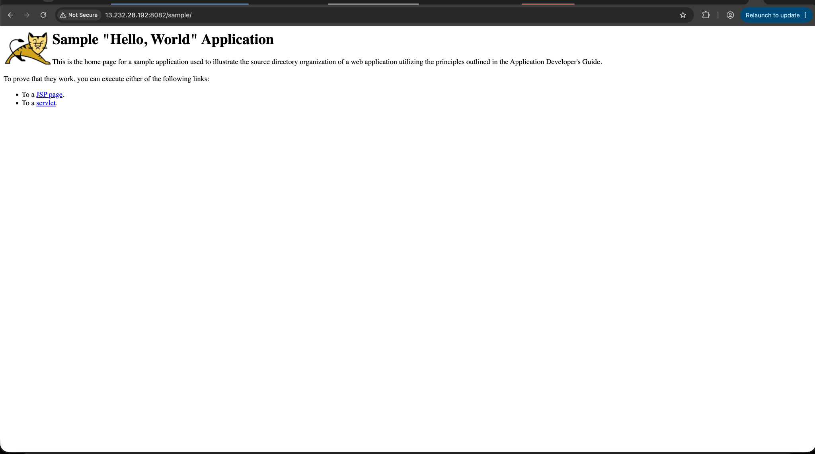

- Create a tomcat.service file for tomcat.
